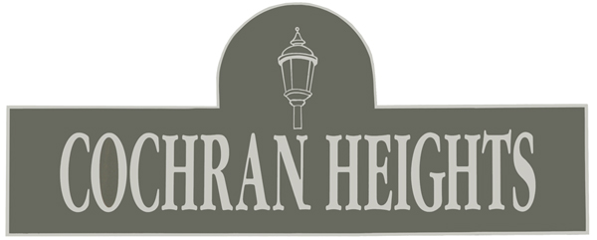

Cochran Heights Gazette
www.cochranheights.com
www.facebook.com/pages/Cochran-Heights/140230294751


XMAS PARTY! December 10, 7-9 PM - The Candle Room

Come join the fun and festivities at this year’s CHNA Christmas party! Thanks to The Candle Room who has once again offered to host the party and provide drink specials for CHNA neighbors. Thanks also to Cuba Libre who will be providing the food again this year!
Admission will be $5, which includes one raffle ticket. Additional raffle tickets can be purchased for $5 each. Raffle prizes have been donated by local businesses including:
- Vickery Park
      - Sushi Axiom
            - Needless Necessities
- Macklin Cleaners
      - The Hacienda on Henderson
            - Premiere Place Lifetime Athletics
- Studios on Willis
      - La Mariposa……and more!

Treasurer’s Note

Current Balance: $ 10,693.29
Balance April 1, 2008: $ 10,693.29

CHNA Officers

President: Mitch Deshotels mldrealtor@yahoo.com
Vice President: Charles Ostermann ostermann9@sbcglobal.net
Secretary: Arlene Colbert
arlene.colbert@hotmail.com
Treasurer: Noreen Grant nonogrant@yahoo.com
Crime Watch: Michael Hamtil
mhamtil@hotmail.com

2009 Good Neighbors

Thank-you to all who donated in 2009! These donations go towards our new median on Henderson, antique lamp installation program, new Cochran Heights street sign toppers, sidewalk replacement program, other general beautification projects and printing costs.

CHNA is now accepting 2010 Good Neighbor donations.

Please don’t rely on your neighbors to improve YOUR neighborhood. Become a Good Neighbor today!

Give or send money to our treasurer Jose Cabrera, 5114 Milam. Checks should be made out to CHNA.

Platinum Neighbors ($300 +)

Shei Unger – 4902 Alcott

Gold Neighbors ($100-$299)

John & Melissa Carpenter - 5034 Alcott
Rusty Glenn – 5102 Homer
Milton & Nicole Sanders – 5115 Alcott
Ismael Gonzalez – 5103 Homer
Greg Armstrong & Alan Rister – 5222 Homer
Sherry & Edward Burke – 5114 Homer
Allen & Cynthia Mondell – 5211 Homer
John & Judy Sullivan – 5217 Homer
George & Judith Kirchwey – 5110 Homer
Noreen Grant – 5114 Milam
Michael Hamtil & Lara Solt – 5106 Milam
Akira Imai – 5207 Milam
Patrick & Gracie Johannsen – 5028 Milam
Wendy Johnston & Rick Grinter – 5110 Milam
Andrew Moulton – 5211 Milam
Charles Ostermann – 5207 Pershing

Silver Neighbors ($50 - $99)

Arlene Colbert – 5206 Alcott
Brian Dearth – 5009 Mission

Bronze Neighbors ($25 - $49)

Mary Cronin & Kent Cobb – 4931 Alcott
Dorothy Chambers – 5102 Milam

Recycling (Blue Bin) Dates

December 17, 31
Jan 14, 28
Feb 11, 25
March 11, 25
Order a blue bin by calling 311 or online at: www.dallascityhall.com/sanitation.html

Bulky Trash Dates

Bulky trash is collected during the third week of each month. Generally, it is picked up on a Wednesday or Thursday. You may be fined for leaving out your bulky trash before the Thursday preceding the pick up week!

Upcoming pick up weeks:

December 15-19
Jan 18 – 22
Feb 15 – 19
March 15 – 19

Cochran Heights Cares!

CHNA has a committee called Cochran Heights Cares that conducts regular visits to those in need, offering services such as shopping, laundry, winterizing, medication pick ups, and simply checking in to make sure all is well.
If you are elderly and would like CH Cares to pay you a visit or you know of someone that you think would appreciate this, please contact Diane Wardrup at dianew@realtyserv.net.

No Mas Al Dia!!

Every Wednesday the Dallas Morning News delivers a free newsletter called ‘Al Dia’ to Dallas area neighborhoods. It comes in a yellow wrapper. Many of you have complained to CHNA about the unsightliness of unclaimed Al Dias on our streets. If you want DMN to discontinue delivering Al Dia to your home, please e-mail nomas@dallasnews.com or call this number: (469) 977-3747.

